PRINTS – CRUD – API SABOR DIGITAL
ANDREW CLARCK

POST
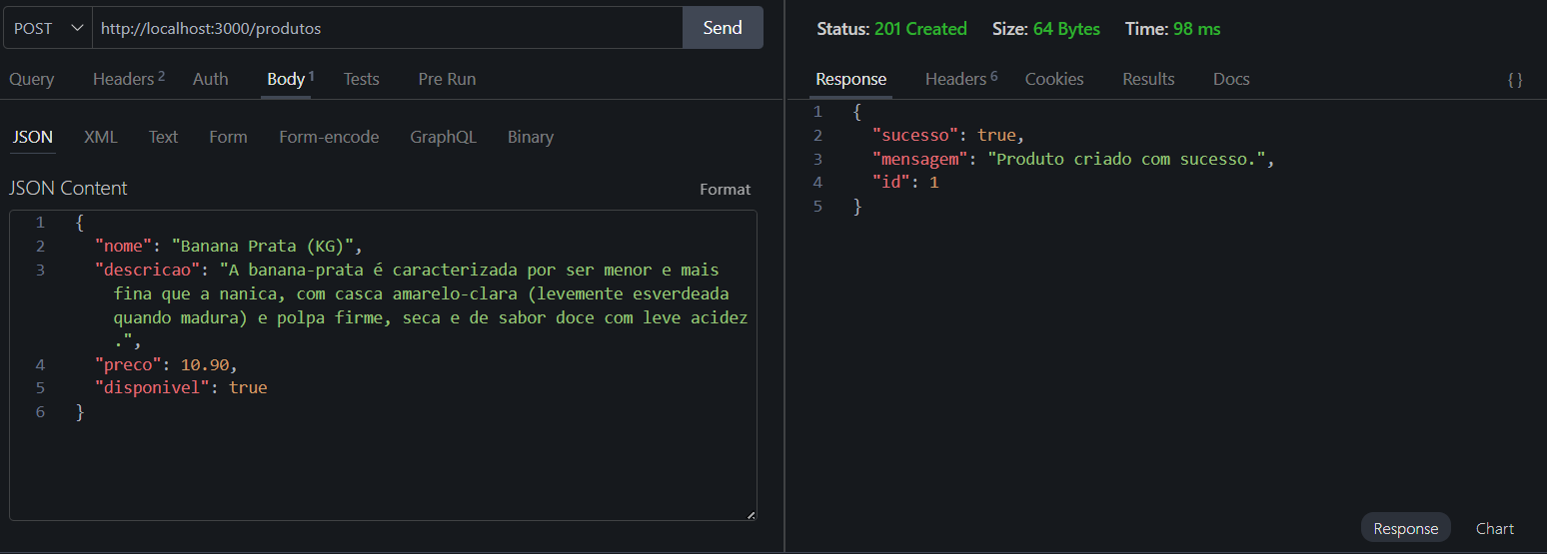
GET
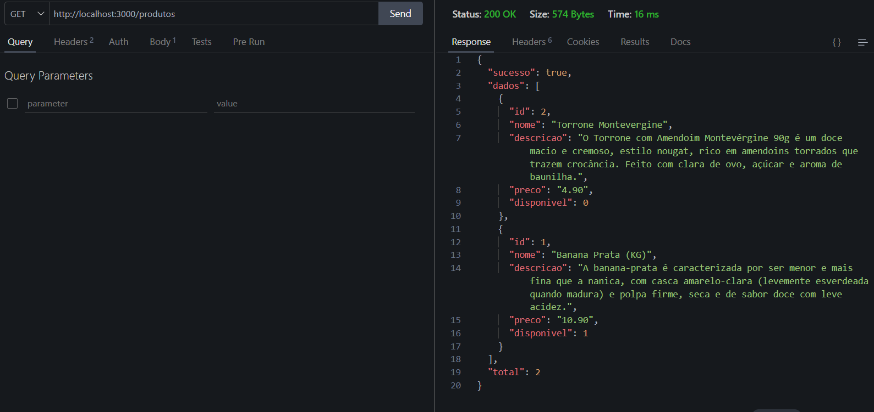
GET com ID
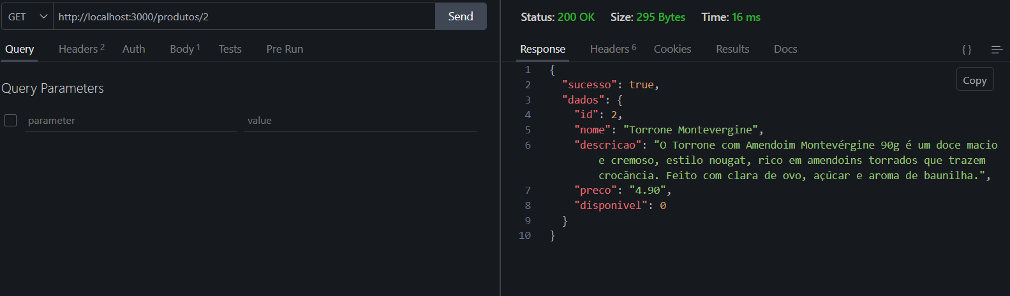

PUT
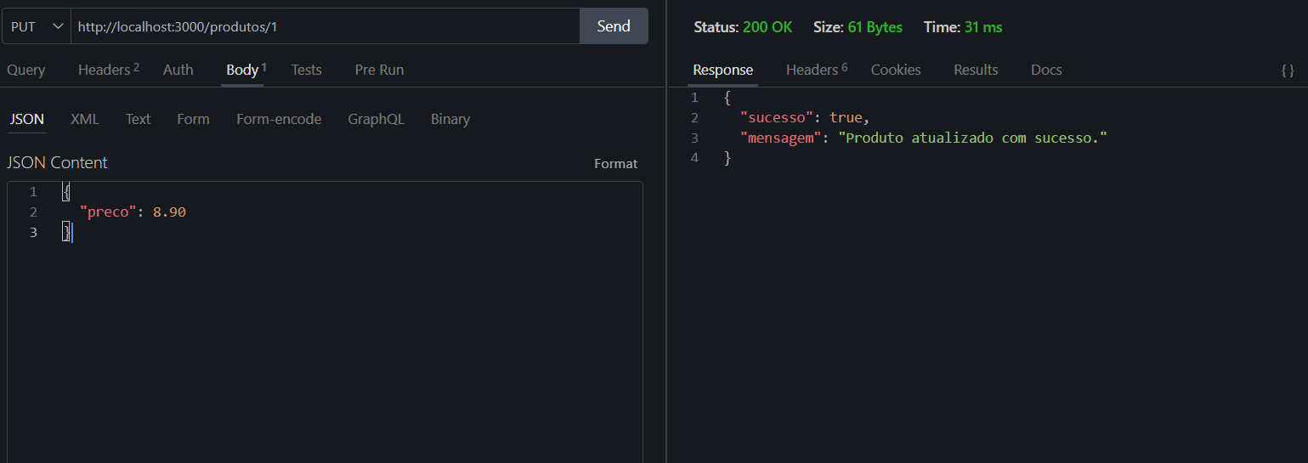
GET no ID 1 após o PUT (preço era 10.90)
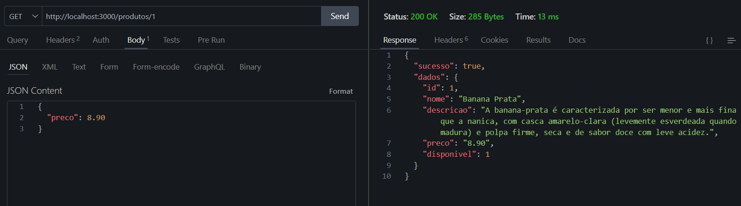
DELETE
